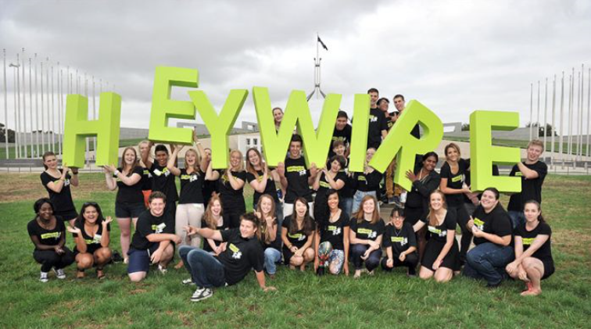

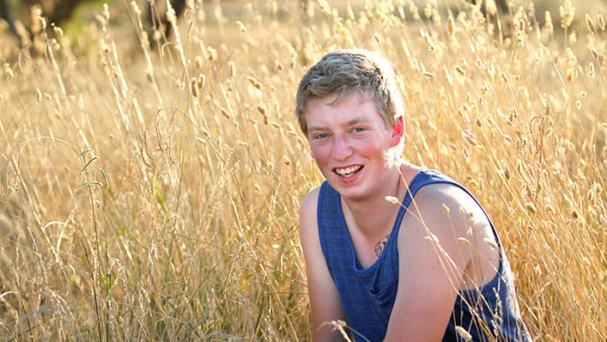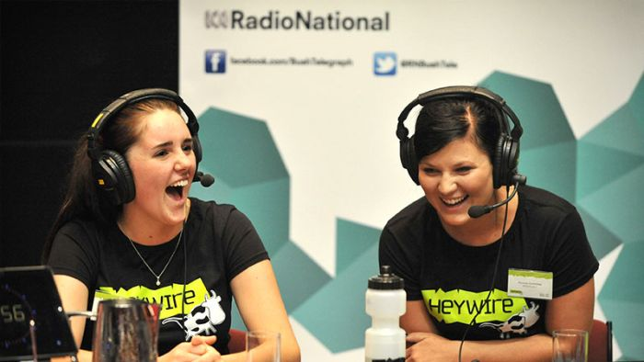



'My school does things differently — like having a day off mid-week'

By Zane Pailthorpe
Posted Tue 10 Dec 2019, 9:27pm Updated Tue 10 Dec 2019, 9:44pm

Heywire winner,

Zane Pailthorpe, South Kolan,

Queensland
It's 6:00am and freezing cold, and for most teenagers, time to start getting ready for school.
But not me — it's a Wednesday and my day off school.
You might be thinking, Wednesday off school?
Yep.
And I'm swimming with thousands of silver perch on a fish farm, 300 kilometres north of Brisbane.
I attend school at the Burnett Youth Learning Centre, but we still call it what it used to be known as, Barry's Farm.
It's a special assistance school for kids who have disengaged from mainstream leaning.
I used to go to a mainstream school, but I didn't make the wisest of choices there.
I made mistakes.
I got caught with some drug paraphernalia in my bag and was suspended.
The chaplain gave me a choice to wait out my suspension or get a referral to Barry's Farm.
It wasn't the easiest decision to make.
It would mean leaving all my friends behind, but I chose to have an introductory day at Barry's Farm and I haven't looked back.
They do things differently here, like having a mid-week break, which is when I go to work on the fish farm.
I carry the crates of fish out of the water, onto the scales, and then put them into a tank on the back of the truck, ready for transport.
It sounds repetitive, but I enjoy it, and it's a great feeling making my own money.
Juggling work with school can be challenging at times, but I'm lucky to have flexibility and support from the teachers who want us to achieve our best.
One of my classes is a gym session, and I've become really interested in fitness — it makes me feel great.
It's inspired me to consider personal training as a career when I leave school.
Overcoming the challenges I'm facing now as a teenager is helping prepare me for the future.
I guess it's how the saying goes: "Give a man a fish, and you feed him for a day. Teach a man to fish, and you feed him for a lifetime".
While I haven't made the best choices in the past, I'm glad that I've ended up where I am.

Complete the following questions about the Heywire story on the previous page.

- What makes Pailthorpe’s story a good story? ____________________________________________

_______________________________________________________________________________________
_______________________________________________________________________________________
_______________________________________________________________________________________
_______________________________________________________________________________________
_______________________________________________________________________________________
- What is Pailthorpe’s main idea? ______________________________________________________

_______________________________________________________________________________________
_______________________________________________________________________________________
_______________________________________________________________________________________
_______________________________________________________________________________________
_______________________________________________________________________________________
_______________________________________________________________________________________
_______________________________________________________________________________________
_______________________________________________________________________________________
- What facts does Pailthorpe use to develop his main argument? ______________________________
_______________________________________________________________________________________
_______________________________________________________________________________________
_______________________________________________________________________________________
_______________________________________________________________________________________
_______________________________________________________________________________________________
_______________________________________________________________________________________________
_______________________________________________________________________________________________
_______________________________________________________________________________________________
- What opinions does Pailthorpe use to develop his main argument? __________________________________
_______________________________________________________________________________________________
_______________________________________________________________________________________________

_______________________________________________________________________________________________
_______________________________________________________________________________________________
_______________________________________________________________________________________________
_______________________________________________________________________________________________
_______________________________________________________________________________________________
- What supporting evidence does Pailthorpe use to develop his main argument? __________________
_______________________________________________________________________________________
_______________________________________________________________________________________
_______________________________________________________________________________________
_______________________________________________________________________________________
_______________________________________________________________________________________
_______________________________________________________________________________________
_______________________________________________________________________________________
- Identify Pailthorpe’s bias. How does he select, omit or emphasise detail to position his listeners/readers?
_______________________________________________________________________________________
_______________________________________________________________________________________
_______________________________________________________________________________________
_______________________________________________________________________________________
_______________________________________________________________________________________
_______________________________________________________________________________________
_______________________________________________________________________________________
_______________________________________________________________________________________
_______________________________________________________________________________________
_______________________________________________________________________________________
_______________________________________________________________________________________
_______________________________________________________________________________________
_______________________________________________________________________________________

My town is hurting but I still hold hope for its future
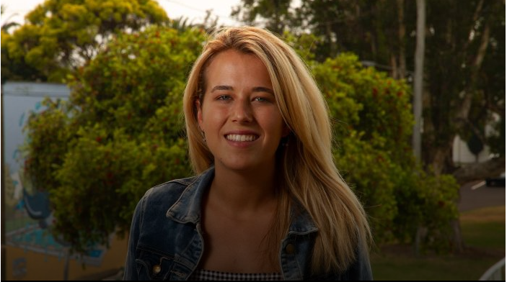
By Fenella Jamieson
Posted Tue 10 Dec 2019, 9:27pm Updated Tue 10 Dec 2019, 9:27pm

Heywire winner Fenella Jamieson,

Narrabri, NSW
I have lots of river memories.
Days filled kayaking, swimming, fishing and exploring.
As a kid growing up with the Namoi River, in north-west New South Wales, I thought this was just normal.
But I've since discovered how rare those river play days actually were.
I'll never forget the day I returned home from university to discover the bone-dry riverbed with my Dad.
Walking down expecting to hear a faint trickle, a splash, a bird but — silence.
I just couldn't believe it. I looked over at my Dad and he looked just as shocked as me.
We've always had years of drought but never like this.
"You can see its bones," my Dad said.
He said this staring at the exposed roots of the trees he planted before I was born, 20 years ago.
They were meant to hold the banks together in the event of a flood.
Grandad ran cattle, then my Dad followed in his footsteps, before turning his hand to cotton farming.
But farming is tough out here and they had several kids who wanted to attend university.
Well, I've always said my education was sponsored by the mines — but I don't blame dad for changing jobs.
I don't blame anyone who wants a secure job!
But as I walk the streets of my hometown, I see empty storefronts with for-sale signs.
People still say 'hi' but seem just as empty as the main street.
I feel like my town is hurting.
Everyone plays the blame game, accusations and attacks.
"Who took the water?"
"It's the cotton farmers!"
"It's the mines!"
"It's climate change!"
"It's the government!"
It's ironic how our town feels like its drowning in a time of drought.
Who has the power to change it?
One of my Dad's biggest goals is to run his own farm again and I really hope he does!
I don't know what will happen to our river, to our town, but I still hold hope for its future.
Not fighting against ourselves, or the land but fighting for it.

Complete the following questions about the Heywire story on the previous page.

- What makes Jamieson’s story a good story? _____________________________________________

_______________________________________________________________________________________
_______________________________________________________________________________________
_______________________________________________________________________________________
_______________________________________________________________________________________
_______________________________________________________________________________________
- What is Jamieson’s main idea? _______________________________________________________

_______________________________________________________________________________________
_______________________________________________________________________________________
_______________________________________________________________________________________
_______________________________________________________________________________________
_______________________________________________________________________________________
_______________________________________________________________________________________
_______________________________________________________________________________________
_______________________________________________________________________________________
- What facts does Jamieson use to develop her main argument? _______________________________
_______________________________________________________________________________________
_______________________________________________________________________________________
_______________________________________________________________________________________
_______________________________________________________________________________________
_______________________________________________________________________________________________
_______________________________________________________________________________________________
_______________________________________________________________________________________________
_______________________________________________________________________________________________
- What opinions does Jamieson use to develop her main argument? __________________________________
_______________________________________________________________________________________________
_______________________________________________________________________________________________

_______________________________________________________________________________________________
_______________________________________________________________________________________________
_______________________________________________________________________________________________
_______________________________________________________________________________________________
_______________________________________________________________________________________________
- What supporting evidence does Jamieson use to develop her main argument? ___________________
_______________________________________________________________________________________
_______________________________________________________________________________________
_______________________________________________________________________________________
_______________________________________________________________________________________
_______________________________________________________________________________________
_______________________________________________________________________________________
_______________________________________________________________________________________
- Identify Jamieson’s bias. How does she select, omit or emphasise detail to position her listeners/readers?
_______________________________________________________________________________________
_______________________________________________________________________________________
_______________________________________________________________________________________
_______________________________________________________________________________________
_______________________________________________________________________________________
_______________________________________________________________________________________
_______________________________________________________________________________________
_______________________________________________________________________________________
_______________________________________________________________________________________
_______________________________________________________________________________________
_______________________________________________________________________________________
_______________________________________________________________________________________
_______________________________________________________________________________________

'Music helped me face my fears in a new town with red dirt'
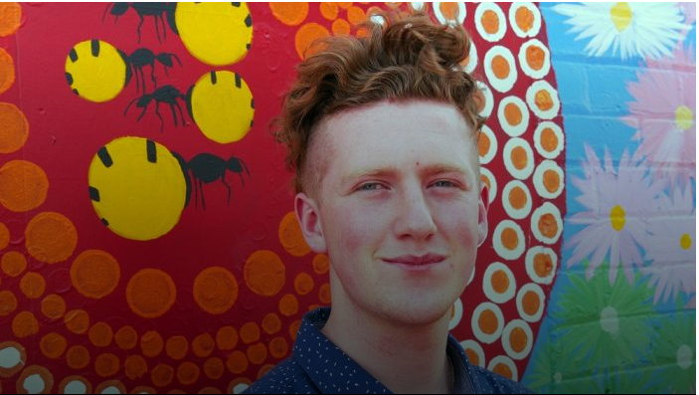
By Blake Hunter
Posted Tue 10 Dec 2019, 9:12pm Updated Tue 10 Dec 2019, 9:12pm

Heywire winner Blake Hunter, Kalgoorlie, WA
I was only young, but I remember how nervous I was
when my family and I moved from Melbourne to
Kalgoorlie.
There were no trams like I was used to, but plenty of red dirt and new faces.
Attending a new school in a new town, I didn't talk to anyone — I just couldn't!
People would try to talk to me but I would shut down and stutter with fear.
I was afraid of being judged — for my looks, my personality and my voice.
I didn't want to be this way, but something happened to me when I was 10 that helped change that.
I was sitting in the back seat of mum's car on a summer's day, holding an icecream, when a song suddenly came onto the radio.
It was Eminem's Love the Way You Lie.
As I listened, my heart pumped faster and my mind raced; what was this music and what was it doing to me?
I was feeling happy and secure in an instant of hearing it.
I remember that feeling because I still have it whenever I listen to rap music.
The beat, the rhythm — I was so intrigued. It was like my world became a little bit larger and I wanted to be part of that world.
I eventually saved up enough coin to buy a music software program that let me produce my own music.
I started watching tutorials on YouTube to learn how to make my own beats.
It took a long time, but eventually I was making my own music and I was feeling great!
I started making new friends and I could start being myself around them.
I'm hoping to join the Police Force when I leave school and work towards being a detective.
I want to help people who might be in trouble, while making cool music beats on the side.
I'm finding out that everyone has personal struggles, but it's important that not to let it define who you are as a person.
I was once timid, shy and afraid — and sometimes I still am — but finding something that can help you get through those hurdles will get you through.
For me — it was rap music!
Complete the following questions about the Heywire story on the previous page.

- What makes Hunter’s story a good story? _______________________________________________

_______________________________________________________________________________________
_______________________________________________________________________________________
_______________________________________________________________________________________
_______________________________________________________________________________________
_______________________________________________________________________________________
- What is Hunter’s main idea? _________________________________________________________

_______________________________________________________________________________________
_______________________________________________________________________________________
_______________________________________________________________________________________
_______________________________________________________________________________________
_______________________________________________________________________________________
_______________________________________________________________________________________
_______________________________________________________________________________________
_______________________________________________________________________________________
- What facts does Hunter use to develop his main argument? _________________________________
_______________________________________________________________________________________
_______________________________________________________________________________________
_______________________________________________________________________________________
_______________________________________________________________________________________
_______________________________________________________________________________________________
_______________________________________________________________________________________________
_______________________________________________________________________________________________
_______________________________________________________________________________________________
- What opinions does Hunter use to develop his main argument? ____________________________________
_______________________________________________________________________________________________
_______________________________________________________________________________________________

_______________________________________________________________________________________________
_______________________________________________________________________________________________
_______________________________________________________________________________________________
_______________________________________________________________________________________________
_______________________________________________________________________________________________
- What supporting evidence does Hunter use to develop his main argument? _____________________
_______________________________________________________________________________________
_______________________________________________________________________________________
_______________________________________________________________________________________
_______________________________________________________________________________________
_______________________________________________________________________________________
_______________________________________________________________________________________
_______________________________________________________________________________________
- Identify Hunter’s bias. How does he select, omit or emphasise detail to position his listeners/readers?
_______________________________________________________________________________________
_______________________________________________________________________________________
_______________________________________________________________________________________
_______________________________________________________________________________________
_______________________________________________________________________________________
_______________________________________________________________________________________
_______________________________________________________________________________________
_______________________________________________________________________________________
_______________________________________________________________________________________
_______________________________________________________________________________________
_______________________________________________________________________________________
_______________________________________________________________________________________
_______________________________________________________________________________________
_______________________________________________________________________________________

'My grandparents showed me how the bush can provide and heal'
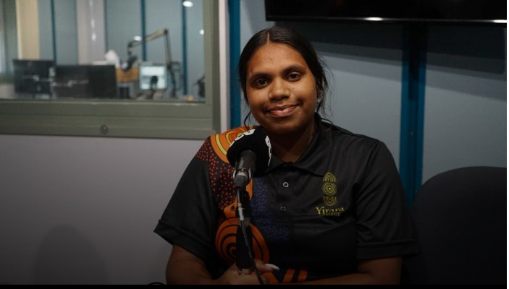
By Telisha Watson
Posted Tue 10 Dec 2019, 9:03pm Updated Tue 10 Dec 2019, 9:03pm

Heywire winner Telisha Watson,

Tennant Creek, Northern Territory
I love going out bush with my grandparents.
They teach me so much about bush tucker and bush medicine.
Every time I don't feel well the food and medicine from out bush helps me feel better.
One night when we were out bush, something happened to my grandfather — he got really sick and started vomiting.
We took him to the hospital because he seemed to be getting worse.
Just as we arrived at the hospital, he passed out and they quickly transferred him to the emergency room.
We were so worried and we stayed with him all through the night.
I felt so scared about what could happen to my grandfather.
So my family decided to go out bush to get some natural herbs and some leaves to make medicine so we could take it to the hospital and give it to Grandad.
The bush medicine must have helped — because he was looking better and started telling me a Dreamtime story about Camooweal and how it got its name and what he used to get up to when he was a young boy.
He would laugh heartily when he got to a point in the story when something silly or unusual happened.
He told me a story about when he and his friend and cousin went fishing, that they threw in a line and waited to get a bite.
Suddenly the line went taut and they all started screaming with excitement at the thought of maybe having caught a delicious barra.
They all held onto the fishing rod for fear of losing their humongous barra that was sure to be a great feed, they reckoned.
The three of them pulled and pulled on the line to bring whatever they had caught closer to the shore.
Tired and sweaty, they laughed until they couldn't laugh anymore when they realised that what they had caught wasn't a huge barramundi, but someone's old boot!
I love my grandad's stories.
Complete the following questions about the Heywire story on the previous page.

- What makes Watson’s story a good story? ______________________________________________

_______________________________________________________________________________________
_______________________________________________________________________________________
_______________________________________________________________________________________
_______________________________________________________________________________________
_______________________________________________________________________________________
- What is Watson’s main idea? _______________________________________________________

_______________________________________________________________________________________
_______________________________________________________________________________________
_______________________________________________________________________________________
_______________________________________________________________________________________
_______________________________________________________________________________________
_______________________________________________________________________________________
_______________________________________________________________________________________
_______________________________________________________________________________________
- What facts does Watson use to develop her main argument? ________________________________
_______________________________________________________________________________________
_______________________________________________________________________________________
_______________________________________________________________________________________
_______________________________________________________________________________________
_______________________________________________________________________________________________
_______________________________________________________________________________________________
_______________________________________________________________________________________________
_______________________________________________________________________________________________
- What opinions does Watson use to develop her main argument? ___________________________________
_______________________________________________________________________________________________
_______________________________________________________________________________________________
_______________________________________________________________________________________________
_______________________________________________________________________________________________
_______________________________________________________________________________________________
_______________________________________________________________________________________________
_______________________________________________________________________________________________
- What supporting evidence does Watson use to develop her main argument? ___________________
_______________________________________________________________________________________
_______________________________________________________________________________________
_______________________________________________________________________________________
_______________________________________________________________________________________
_______________________________________________________________________________________
_______________________________________________________________________________________
_______________________________________________________________________________________
- Identify Watson’s bias. How does she select, omit or emphasise detail to position her listeners/readers?
_______________________________________________________________________________________
_______________________________________________________________________________________
_______________________________________________________________________________________
_______________________________________________________________________________________
_______________________________________________________________________________________
_______________________________________________________________________________________
_______________________________________________________________________________________
_______________________________________________________________________________________
_______________________________________________________________________________________
_______________________________________________________________________________________
_______________________________________________________________________________________

